BigQuery Profile in dbt
A BigQuery profile in dbt is simply the connection configuration that tells your local dbt project how to connect to Google BigQuery and where dbt should create its models.
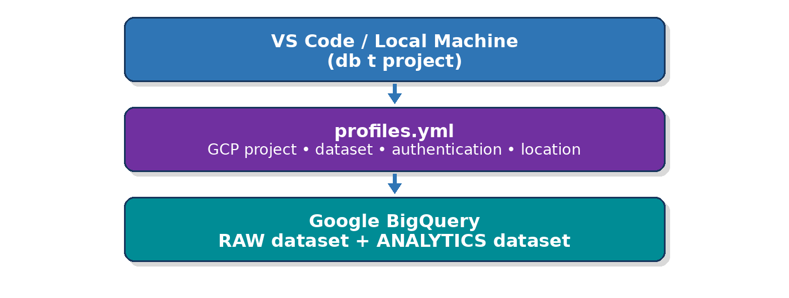
The profile is not a transformation file. Your SQL transformations remain inside `models/`; the profile only answers:
Where should dbt connect, how should it authenticate, and where should it build the models?
BigQuery permissions also matter: running query jobs requires BigQuery job permissions, while creating/updating tables requires data-edit permissions on the destination dataset. Google specifically documents `BigQuery Job User` and `BigQuery Data Editor` as typical roles for running jobs and creating/loading/querying tables.

Simple Real-World Use Case
Suppose an e-commerce company has these raw BigQuery tables:
CUSTOMERS
ORDERS
Management wants:
Customer
Total Orders
Total Revenue
Customer Category
For example:
Ravi 3 42000 GOLD
Priya 2 18000 SILVER
John 1 4000 BRONZE
We will build:
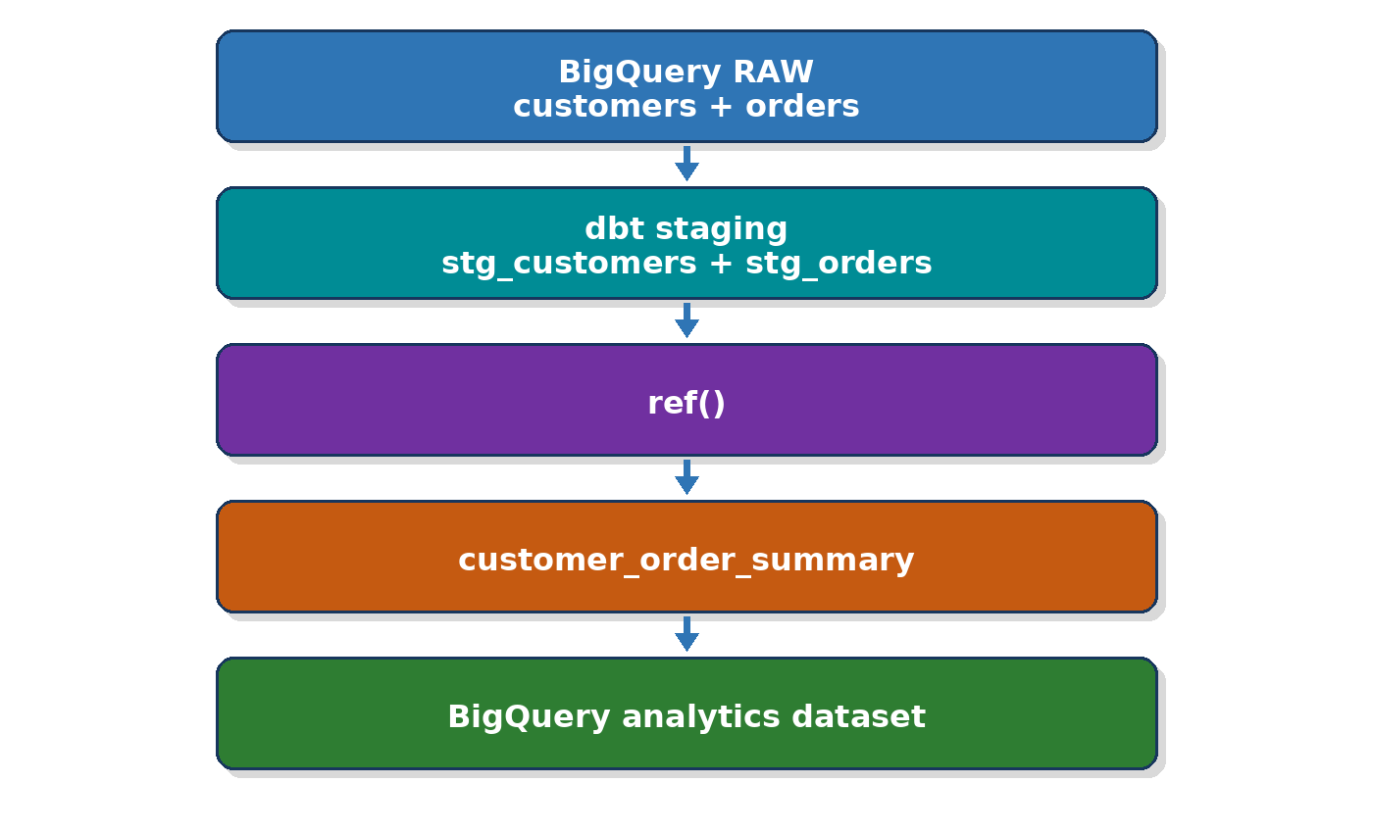

Where do we implement everything?
Use two places.

On your local machine / VS Code
Keep:
dbt project
models/
seeds/
snapshots/
tests/
dbt_project.yml
profiles.yml

In Google BigQuery
Keep:
Raw tables
Transformed views
Transformed tables
Final marts
So:
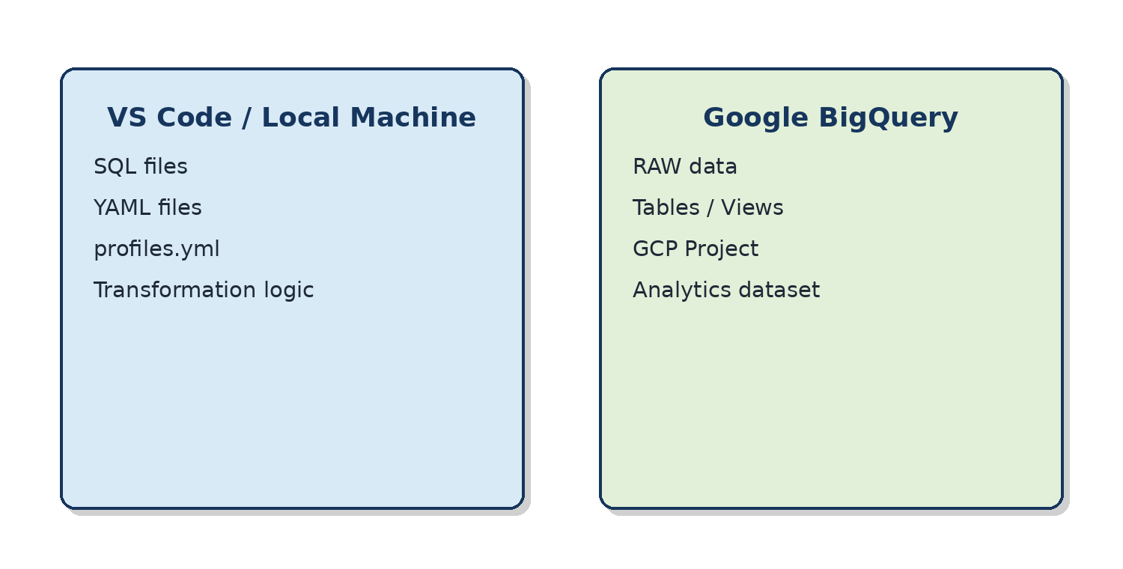

Step 1 — Prepare Google Cloud
Open:
Google Cloud Console → BigQuery
Select your training project.
For example:
Project:
bigquery-optimization-lab
We'll create two datasets:
dbt_training_raw
dbt_training_analytics
A BigQuery dataset is the container in which tables and other BigQuery resources are organized. Dataset creation requires appropriate permissions such as those included in BigQuery Data Editor, Data Owner, User, or Admin roles.

Step 2 — Create RAW dataset
In BigQuery:
Project
↓
⋮
↓
Create dataset
Dataset ID:
dbt_training_raw
Location:
US
or whatever region you are using consistently.

Important
Remember the location.
We'll need it in the dbt profile.

Step 3 — Create Analytics dataset
Create another dataset:
dbt_training_analytics
Use the same BigQuery location.
Our architecture becomes:
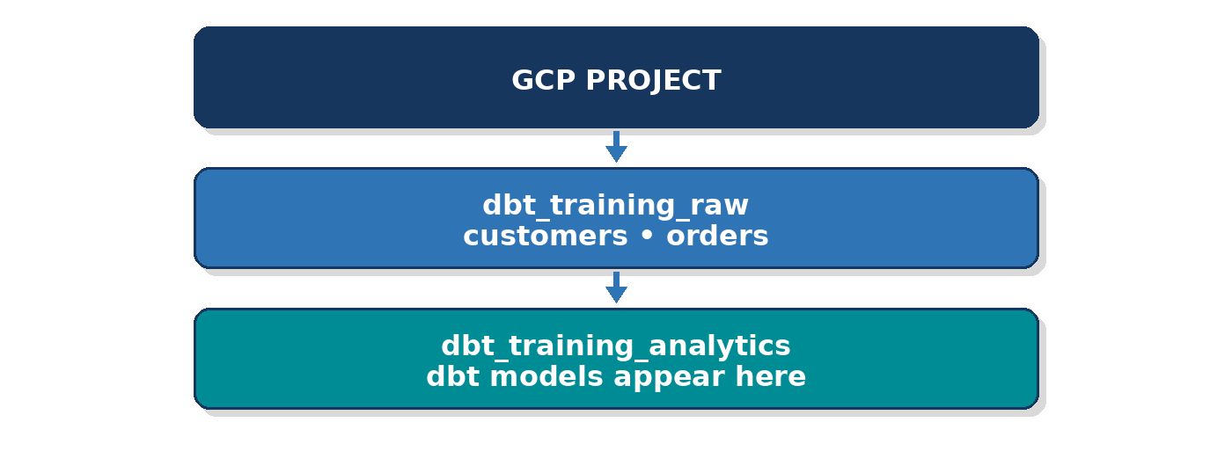

Step 4 — Create sample customer table
In BigQuery SQL workspace:
CREATE OR REPLACE TABLE
`your-project-id.dbt_training_raw.customers`
(
customer_id INT64,
customer_name STRING,
country STRING
);
Insert data:
INSERT INTO
`your-project-id.dbt_training_raw.customers`
VALUES
(1, 'Ravi', 'India'),
(2, 'Priya', 'India'),
(3, 'John', 'USA'),
(4, 'Sara', 'UK'),
(5, 'David', 'USA');
Replace:
your-project-id
with your actual GCP project ID.

Step 5 — Create orders
CREATE OR REPLACE TABLE
`your-project-id.dbt_training_raw.orders`
(
order_id INT64,
customer_id INT64,
order_date DATE,
amount NUMERIC,
status STRING
);
Insert:
INSERT INTO
`your-project-id.dbt_training_raw.orders`
VALUES
(1001, 1, '2026-08-01', 15000, 'COMPLETED'),
(1002, 1, '2026-08-02', 12000, 'COMPLETED'),
(1003, 1, '2026-08-04', 15000, 'COMPLETED'),
(1004, 2, '2026-08-02', 10000, 'COMPLETED'),
(1005, 2, '2026-08-05', 8000, 'COMPLETED'),
(1006, 3, '2026-08-03', 4000, 'COMPLETED'),
(1007, 4, '2026-08-04', 25000, 'COMPLETED'),
(1008, 5, '2026-08-05', 6000, 'CANCELLED');
Checkpoint:
SELECT *
FROM `your-project-id.dbt_training_raw.customers`;
SELECT *
FROM `your-project-id.dbt_training_raw.orders`;

Step 6 — What permissions does dbt need?
For a simple classroom setup, the identity used by dbt needs to be able to:
Run BigQuery jobs
Read source data
Create/update dbt output tables/views
A common training combination is:
BigQuery Job User
+
BigQuery Data Editor
Google documents `roles/bigquery.jobUser` for running query/load jobs and `roles/bigquery.dataEditor` for creating tables, loading data, and querying the dataset.
For production, you'd normally scope permissions more narrowly rather than giving broad project-wide access.

Step 7 — Local VS Code setup
Now move to your machine.
Create a folder:
mkdir bigquery_dbt_demo
Enter it:
cd bigquery_dbt_demo
Create Python virtual environment:
python -m venv .venv
Activate:
.venv\Scripts\Activate.ps1

Step 8 — Install dbt BigQuery adapter
pip install dbt-bigquery
Check:
dbt --version
You should see BigQuery adapter information alongside the dbt installation.

Step 9 — Create the dbt project
Run:
dbt init ecommerce_bigquery
Enter the project:
cd ecommerce_bigquery
Open:
code .
Your project will look similar to:
ecommerce_bigquery/
│
├── models/
│
├── seeds/
│
├── snapshots/
│
├── tests/
│
├── macros/
│
└── dbt_project.yml

Step 10 — Now understand the BigQuery Profile
This is the key part.
dbt needs to know:
Which GCP project?
Which BigQuery dataset?
How should I login?
Which location?
How many concurrent operations?
That information goes into:
profiles.yml
On Windows, dbt commonly looks in:
C:\Users\<your-user>\.dbt\profiles.yml
For example:
C:\Users\LENOVO\.dbt\profiles.yml

Step 11 — Simplest authentication for classroom demo
For your own machine, I recommend starting with:

OAuth
The profile conceptually looks like:
ecommerce_bigquery:
target: dev
outputs:
dev:
type: bigquery
method: oauth
project: YOUR_GCP_PROJECT_ID
dataset: dbt_training_analytics
location: US
threads: 4
Example:
ecommerce_bigquery:
target: dev
outputs:
dev:
type: bigquery
method: oauth
project: bigquery-optimization-lab
dataset: dbt_training_analytics
location: US
threads: 4

What does every property mean?
Property | Meaning
type | Database adapter
bigquery | We're connecting to BigQuery
method | Authentication mechanism
oauth | Use Google credentials
project | GCP project ID
dataset | Default BigQuery dataset for dbt output
location | BigQuery region
threads | Parallel dbt execution
target | Environment being used

The most important one for freshers is:
dataset: dbt_training_analytics
It means:
By default, dbt should build my models inside this BigQuery dataset.

BigQuery vs Snowflake profile
This is a good teaching comparison.

Snowflake profile
You normally configure:
account
user
role
warehouse
database
schema

BigQuery profile
You configure concepts such as:
project
dataset
authentication method
location
Why is there no Snowflake-style warehouse name?
Because the platforms have different architectures.
For freshers:
Snowflake
Database
↓
Schema
↓
Tables
BigQuery
Project
↓
Dataset
↓
Tables
So you can mentally compare:
Snowflake database/schema
roughly corresponds to
BigQuery project/dataset
Not technically identical, but useful as an introductory mental model.

Step 12 — Authenticate Google locally
For OAuth development, install/use the Google Cloud CLI and authenticate your local environment.
One common approach is Application Default Credentials:
gcloud auth application-default login
Your browser opens.
Select your Google account.
Grant access.
Then your local dbt process can obtain Google credentials through ADC.

Step 13 — Test the BigQuery profile
Run:
dbt debug
What is happening?
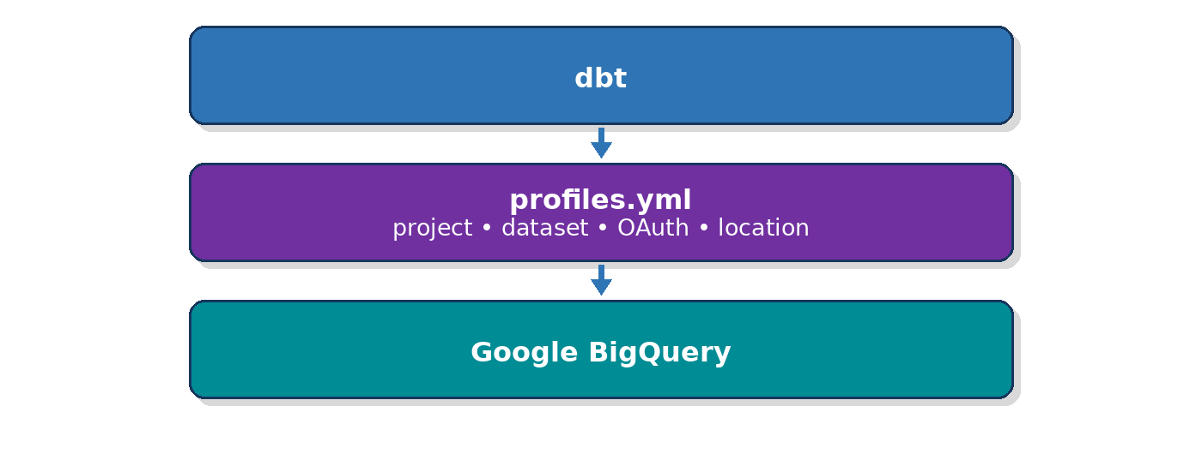
Expected:
Connection test: OK

This is the most important profile checkpoint.
If `dbt debug` fails, don't create models yet.

Step 14 — Create dbt source
Now tell dbt where the RAW tables are.
Create:
models/staging/sources.yml
version: 2
sources:
- name: ecommerce_raw
database: YOUR_GCP_PROJECT_ID
schema: dbt_training_raw
tables:
- name: customers
- name: orders
Example:
version: 2
sources:
- name: ecommerce_raw
database: bigquery-optimization-lab
schema: dbt_training_raw
tables:
- name: customers
- name: orders
Now:
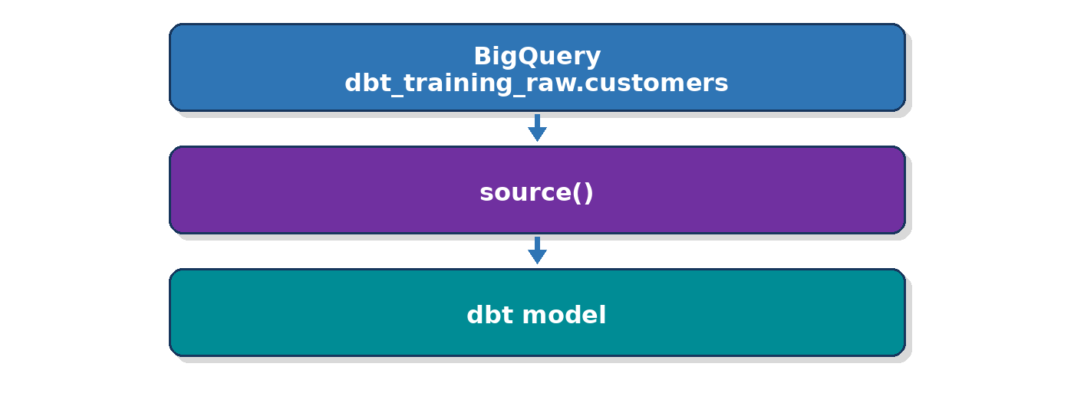

Step 15 — Create customer staging model
Create:
models/staging/stg_customers.sql
SELECT
customer_id,
UPPER(TRIM(customer_name))
AS customer_name,
UPPER(TRIM(country))
AS country
FROM {{ source('ecommerce_raw', 'customers') }}
Business purpose:
Raw customers
↓
Clean customer names
↓
Standardized countries

Step 16 — Create order staging
Create:
models/staging/stg_orders.sql
SELECT
order_id,
customer_id,
order_date,
amount,
UPPER(TRIM(status))
AS status
FROM {{ source('ecommerce_raw', 'orders') }}
WHERE status = 'COMPLETED'
Now cancelled orders don't enter our sales analytics.

Step 17 — Run staging models
dbt run --select staging
Now look at BigQuery.
You should see objects under:
dbt_training_analytics
Something like:
dbt_training_analytics
│
├── stg_customers
└── stg_orders
This proves your BigQuery profile is working.
The profile told dbt:
CREATE MY MODELS HERE
↓
dbt_training_analytics

Step 18 — Create final business model
Create:
models/marts/customer_revenue.sql
Use:
SELECT
c.customer_id,
c.customer_name,
c.country,
COUNT(o.order_id)
AS total_orders,
SUM(o.amount)
AS total_revenue,
CASE
WHEN SUM(o.amount) >= 30000
THEN 'GOLD'
WHEN SUM(o.amount) >= 10000
THEN 'SILVER'
ELSE 'BRONZE'
END AS customer_category
FROM {{ ref('stg_customers') }} c
INNER JOIN {{ ref('stg_orders') }} o
ON c.customer_id = o.customer_id
GROUP BY
c.customer_id,
c.customer_name,
c.country

Step 19 — Understand `ref()`
Notice:
{{ ref('stg_customers') }}
not:
dbt_training_analytics.stg_customers
And:
{{ ref('stg_orders') }}
dbt therefore understands:
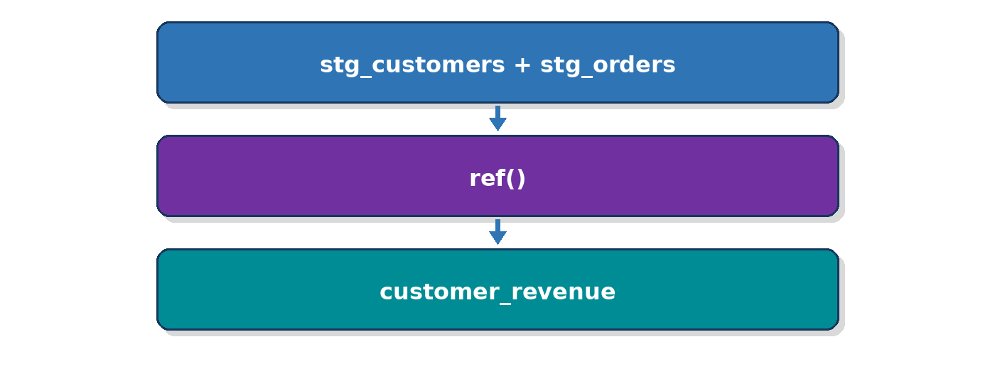

Step 20 — Run final model
dbt run --select customer_revenue
Then query BigQuery:
SELECT *
FROM `YOUR_PROJECT.dbt_training_analytics.customer_revenue`
ORDER BY total_revenue DESC;
Expected conceptually:
Customer | Orders | Revenue | Category
Ravi | 3 | 42000 | GOLD
Sara | 1 | 25000 | SILVER
Priya | 2 | 18000 | SILVER
John | 1 | 4000 | BRONZE

Step 21 — Add simple tests
Create:
models/staging/staging.yml
version: 2
models:
- name: stg_customers
columns:
- name: customer_id
data_tests:
- unique
- not_null
- name: stg_orders
columns:
- name: order_id
data_tests:
- unique
- not_null
- name: customer_id
data_tests:
- not_null
- relationships:
arguments:
to: ref('stg_customers')
field: customer_id
Run:
dbt test

Step 22 — Final architecture
This is the diagram I would use while teaching:
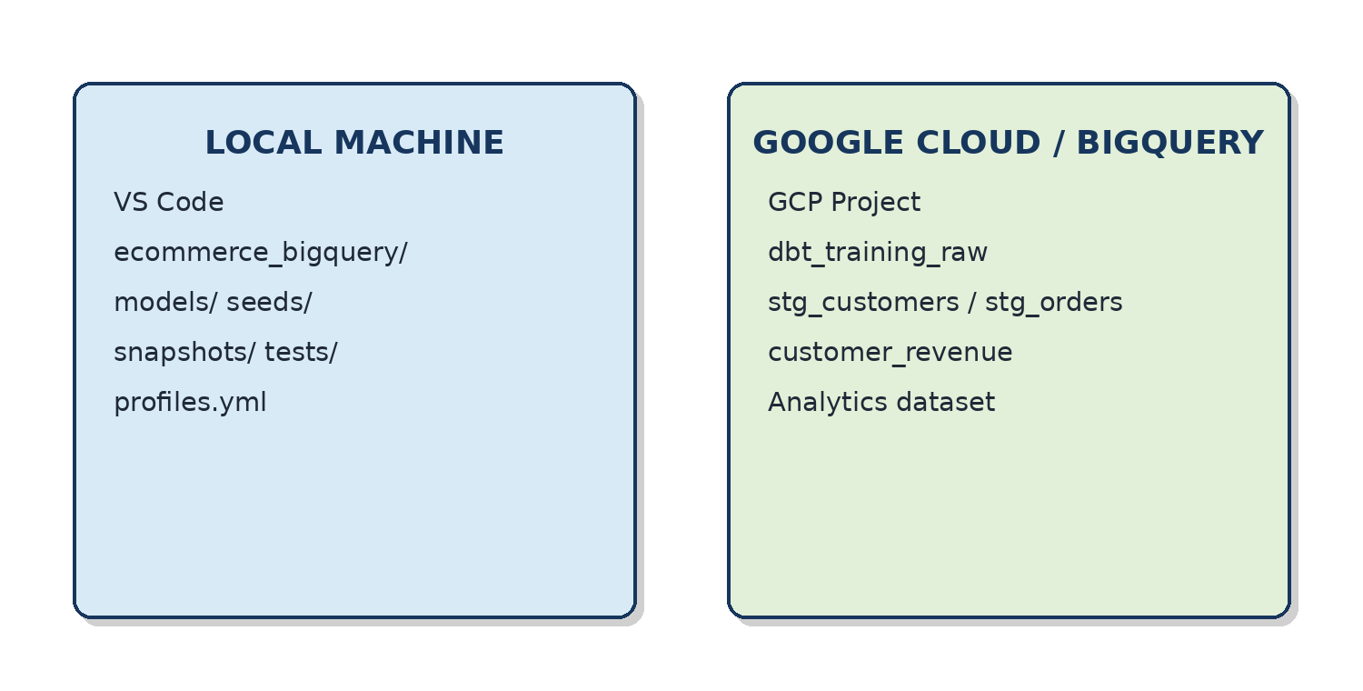

What exactly did the BigQuery profile do?
Without the profile:
dbt project
"Where is BigQuery?"
"Which GCP project?"
"How should I authenticate?"
"Where should I create models?"
Unknown ❌
With:
type: bigquery
method: oauth
project: bigquery-optimization-lab
dataset: dbt_training_analytics
location: US
dbt understands:
Database platform
↓
BigQuery
Authentication
↓
Google OAuth
GCP Project
↓
bigquery-optimization-lab
Destination
↓
dbt_training_analytics
Region
↓
US
That is the simplest meaning of a BigQuery dbt profile.

OAuth vs Service Account
For your fresher demonstration, I'd start with:
OAuth
because it is easier to explain:
Student
↓
Google login
↓
dbt
↓
BigQuery
For automated production pipelines, a service-account-based setup is often more suitable because the workload runs as a non-human identity with specifically granted IAM permissions. Google recommends predefined IAM roles rather than broad basic roles such as Owner or Editor.
Conceptually:
Development
VS Code
↓
OAuth
↓
BigQuery
Automation / CI/CD
Pipeline
↓
Service Account
↓
BigQuery

Profile vs Source — very important
Students frequently confuse these.

`profiles.yml`
Answers:
Where does my dbt project run?
project: my-gcp-project
dataset: dbt_training_analytics

`sources.yml`
Answers:
Where is my raw data?
database: my-gcp-project
schema: dbt_training_raw
So:
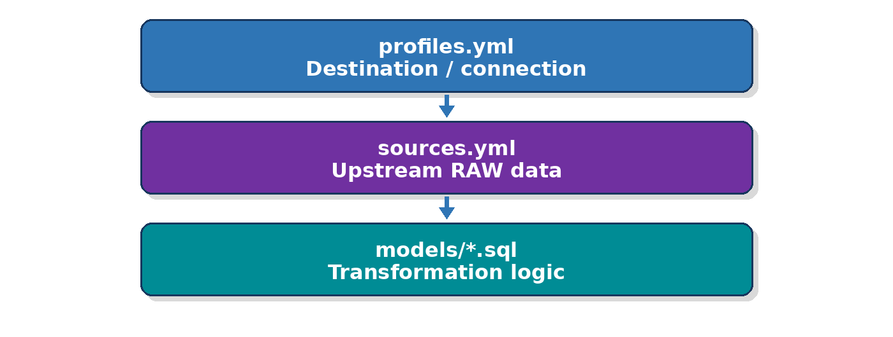

Best fresher demo sequence
- Show two raw BigQuery tables.
- Explain Project → Dataset → Table.
- Create `dbt_training_analytics`.
- Install `dbt-bigquery`.
- Create dbt project.
- Open `profiles.yml`.
- Explain every profile property.
- Authenticate with Google.
- Run `dbt debug` and show Connection OK.
- Define RAW tables using `source()`.
- Create one staging model.
- Run it and immediately show the model appearing in BigQuery.
- Create the second staging model.
- Create a final model using `ref()`.
- Run tests.
- Finally redraw the lineage.
The important "wow moment" for freshers is:
I wrote this:
stg_customers.sql
↓
I ran dbt
↓
A BigQuery view/table appeared
↓
profiles.yml decided WHERE it appeared.
That's the easiest way to make the BigQuery profile concept stick.

